**SOP for Logging into VDI**

**Prepared By**

**Ponnaganti Sravani**



Wipro Technologies

MAY 2019

Copyright Acknowledgment

Any registered names, trademarks and logos used in this manual remain the property of the owning respective companies or organisations concerned.

This documentation may in whole or in part, be copied or replicated to any electronic medium for use within Wipro Technologies only. All copies that are made shall retain all copyright notices.

Disclaimer

The documentation is prepared based on the specifications and technical information specified or known to Wipro Technologies.

The contents Changes are periodically added to the information herein: these changes will be incorporated in subsequent version(s) of the documentation. Wipro may make improvements and / or changes in the documentation.

Trademark Acknowledgment

Wipro is a registered trademark of Wipro Limited.

This SOP describes on How to Login to MY-Connect Wipro VDI basis the latest changes that have taken place in Infrastructure after the Implementation of MFA in My-Connect VDI Infra.

**Pre-Requisites**: (Below Details are **MANDATORY** to log into VDI)

* Make sure you have Citrix Receiver version 4.9.6001+ version is installed in your Base machine through which you are trying to access your VDI.
* Update Cell details in, **My Wipro -> My Data -> My Office details**.
* Update details in <https://aka.ms/mfasetup> (select ‘Text code to my…..’)
* Register Cell details in <https://accountservices.wipro.com>
* In-case of any issue, reach IMG AD team on [socopr-grp@wipro.com](mailto:socopr-grp@wipro.com) / [Msoft-opr@wipro.com](mailto:Msoft-opr@wipro.com)
* Note: For non-Wipro / Contractor employees, pls reach your respective SPOC’s in Wipro, to further share your Cell & AD Id details with IMG AD team ([socopr-grp@wipro.com](mailto:socopr-grp@wipro.com) / [Msoft-opr@wipro.com](mailto:Msoft-opr@wipro.com)), for registration from backend.

**Step-By-Step** Procedure

**Step 1:** Browse your respective VDI URL.

<https://pdc-myconnect.wipro.com>

https://pdc-ica-myconnect.wipro.com (For Charles Schwab Users Only)

**Step 2:** Please enter your User Name and Password and click on “Log On”

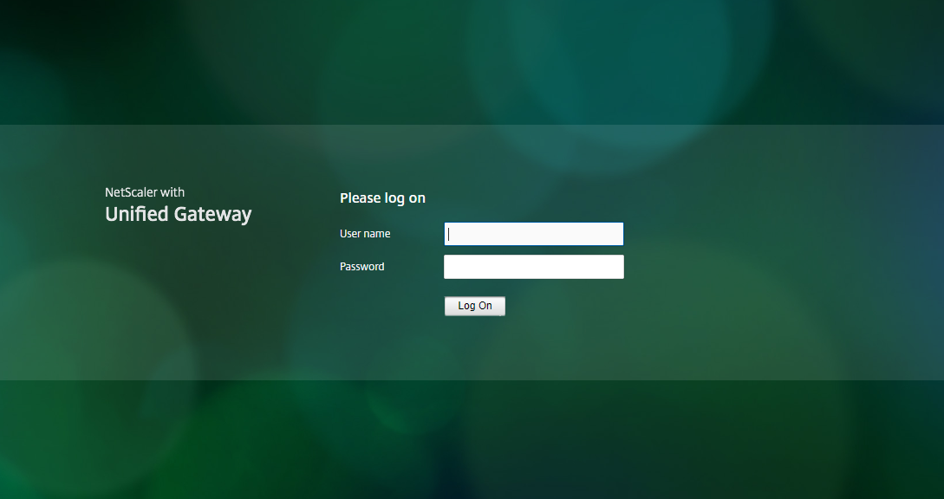

**Step 3:** After “log on” you will receive an OTP to your registered Mobile Number which is registered in your Mywipro>MyData>Official Details and registered for MFA. Please enter the OTP as shown in the below screen. Click on “Submit”. You are able to Login successfully.



**Step 4** (Only if required):

If you get the below error even after entering the OTP, Please reset your AD Password and check once.

